1. SELECT item_num, description, price

FROM Item;

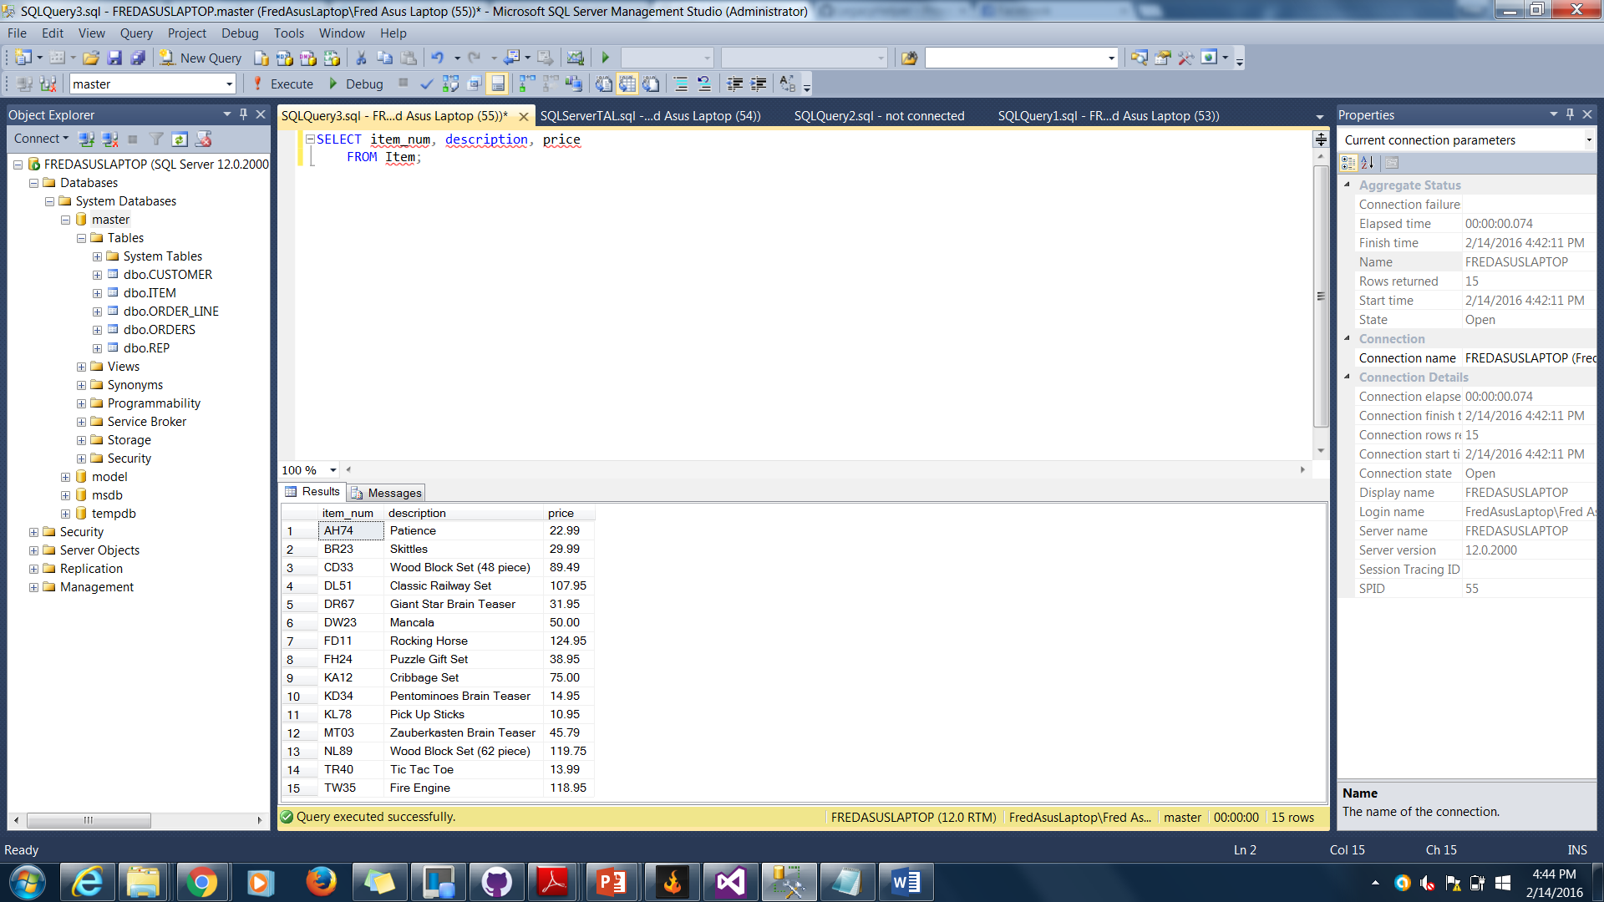

1. SELECT *

FROM Orders

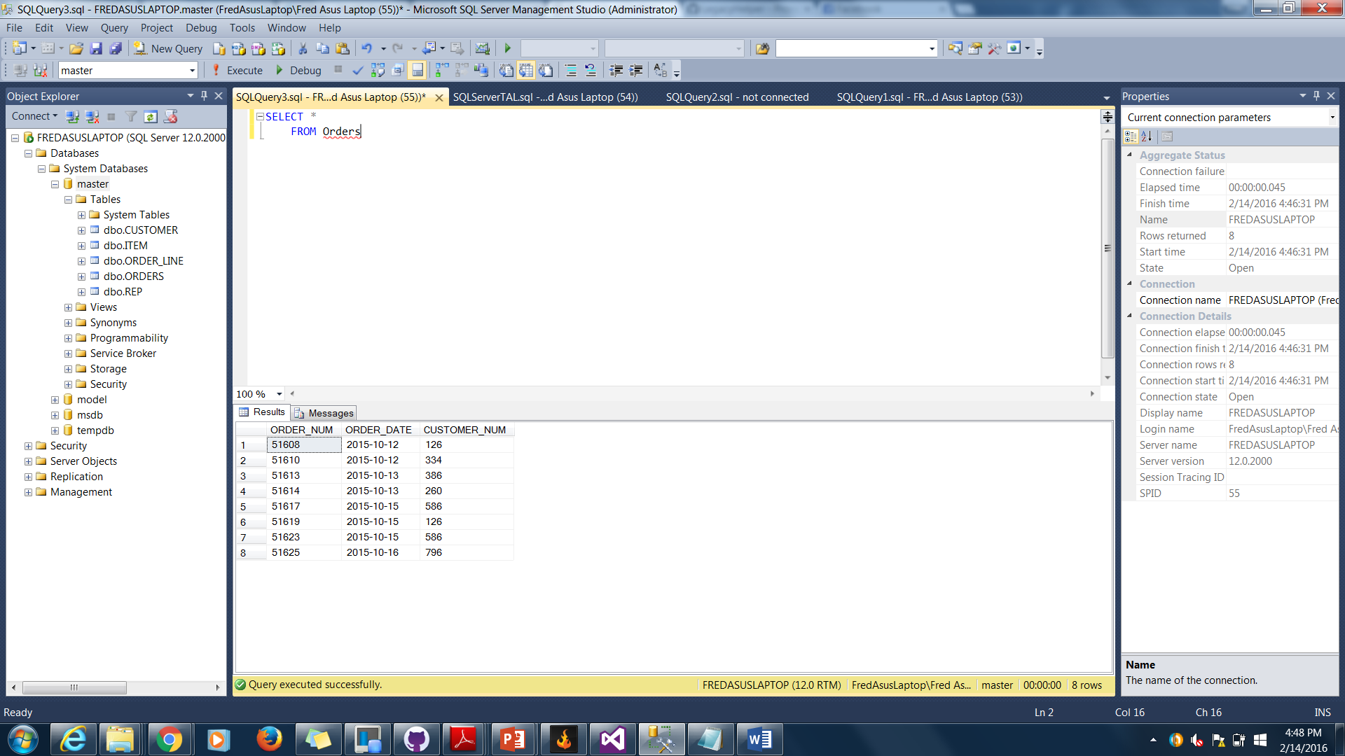

1. SELECT CUSTOMER_NAME

FROM CUSTOMER

WHERE credit_limit >= '10000'

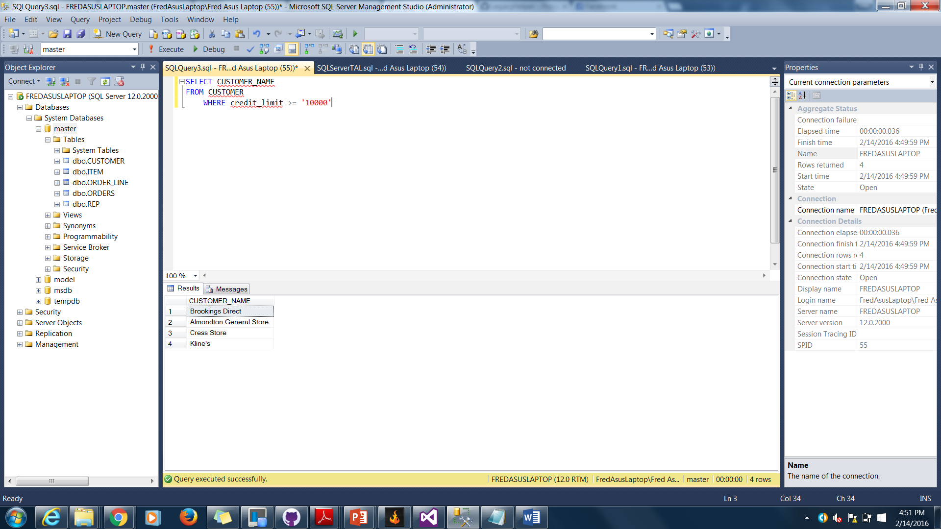

1. SELECT Order_num

FROM Orders

WHERE customer_num = '126' AND order_date = '10/15/2015'

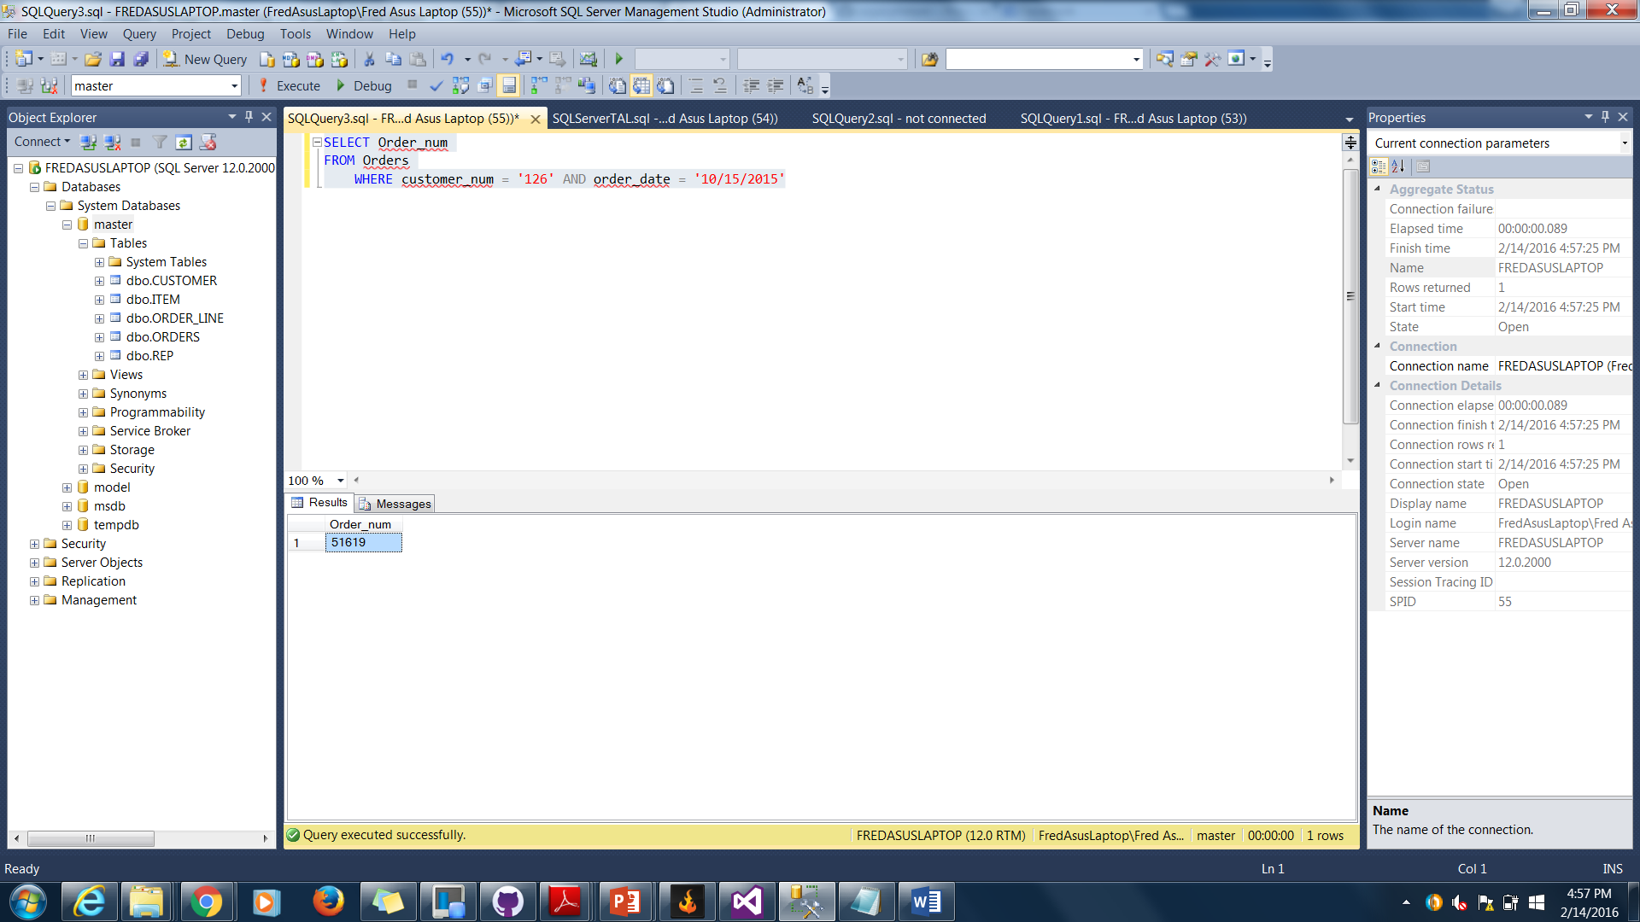

1. SELECT customer_num, customer_name

FROM CUSTOMER

WHERE rep_num = '30' OR rep_num = '45'

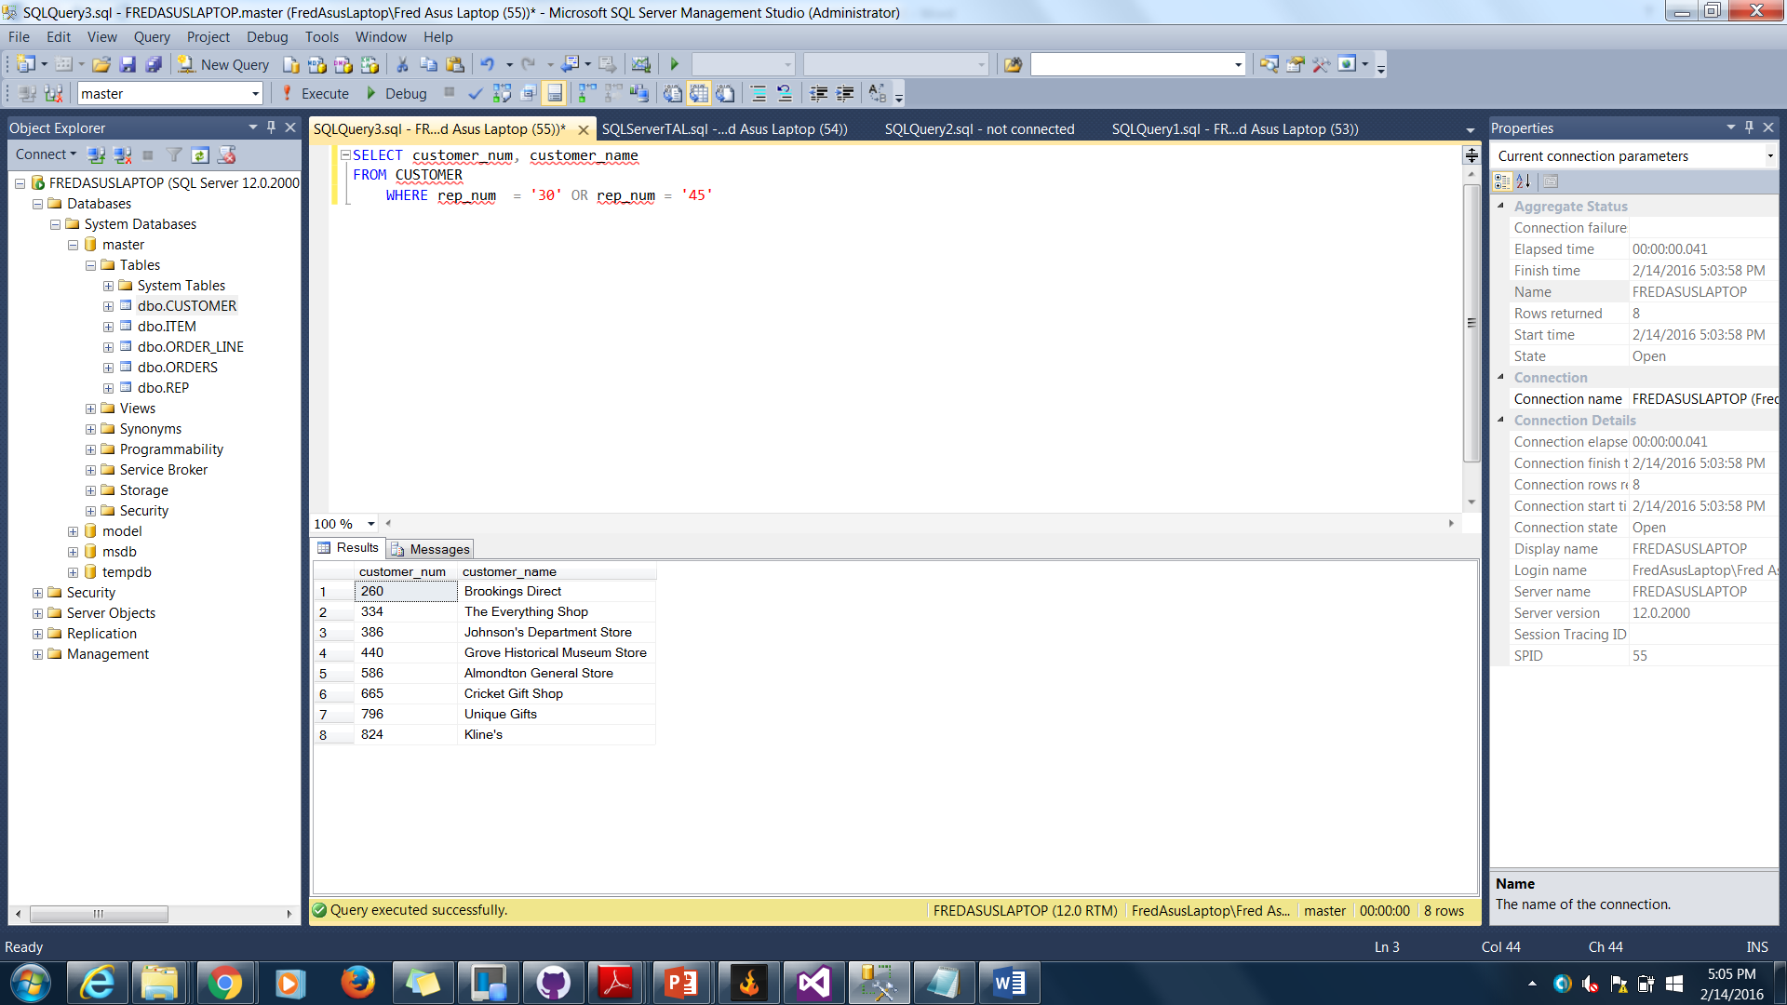

1. SELECT item_num, description

FROM ITEM

WHERE category != 'PZL'

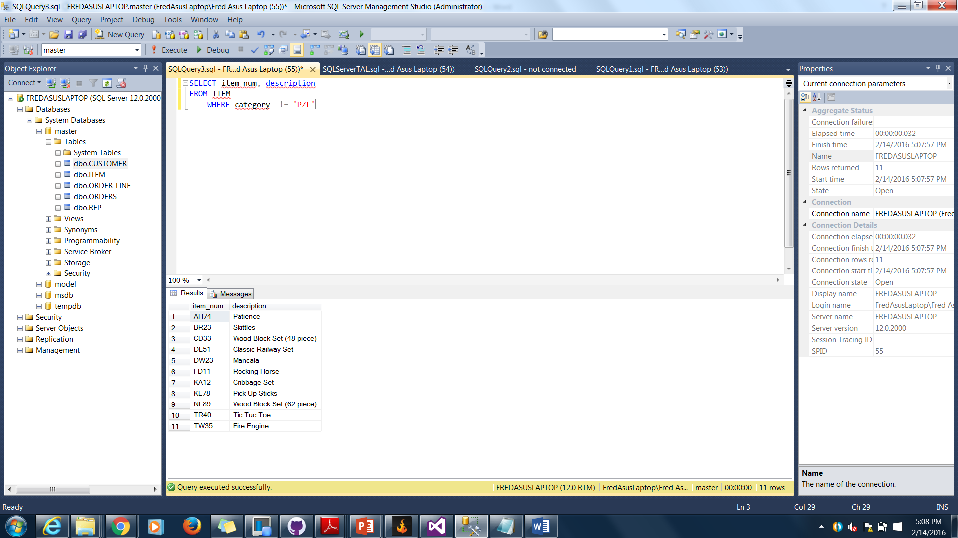

1. SELECT item_num, description, on_hand

FROM ITEM

WHERE on_hand between '20' AND '40'

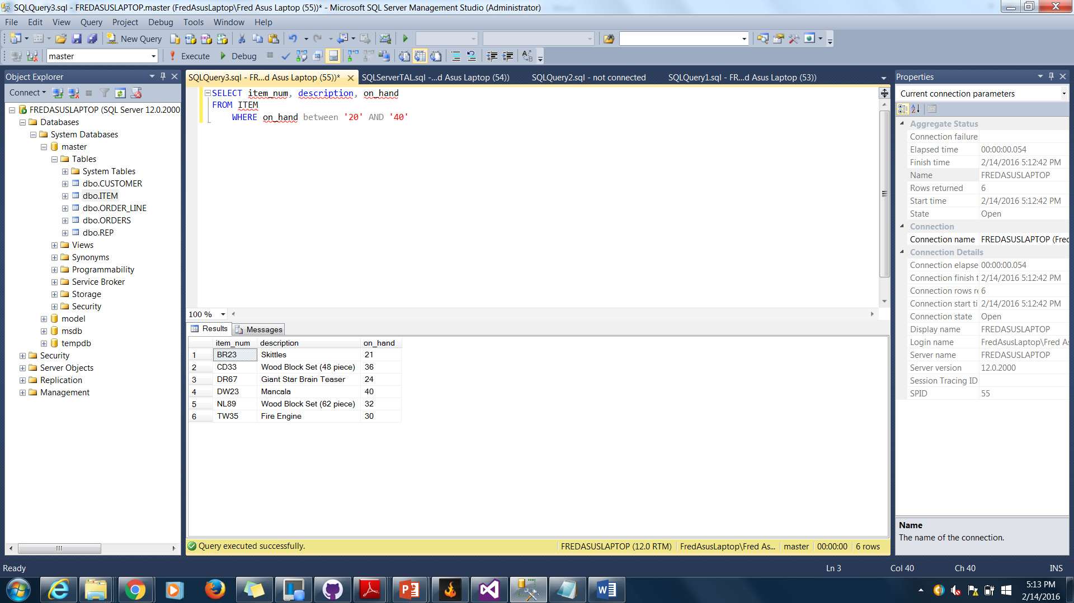

1. SELECT item_num, description, (on_hand * price) as ON_HAND_VALUE

FROM ITEM

WHERE CATEGORY = 'TOY'

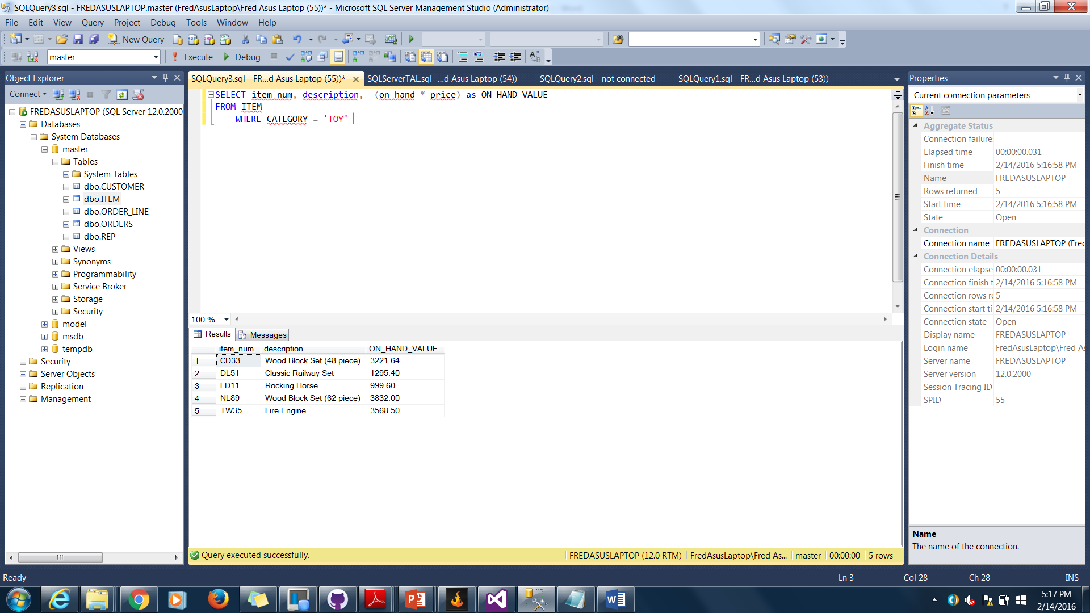

1. SELECT item_num, description, (on_hand * price) as ON_HAND_VALUE

FROM ITEM

WHERE on_hand * price >= '1500'

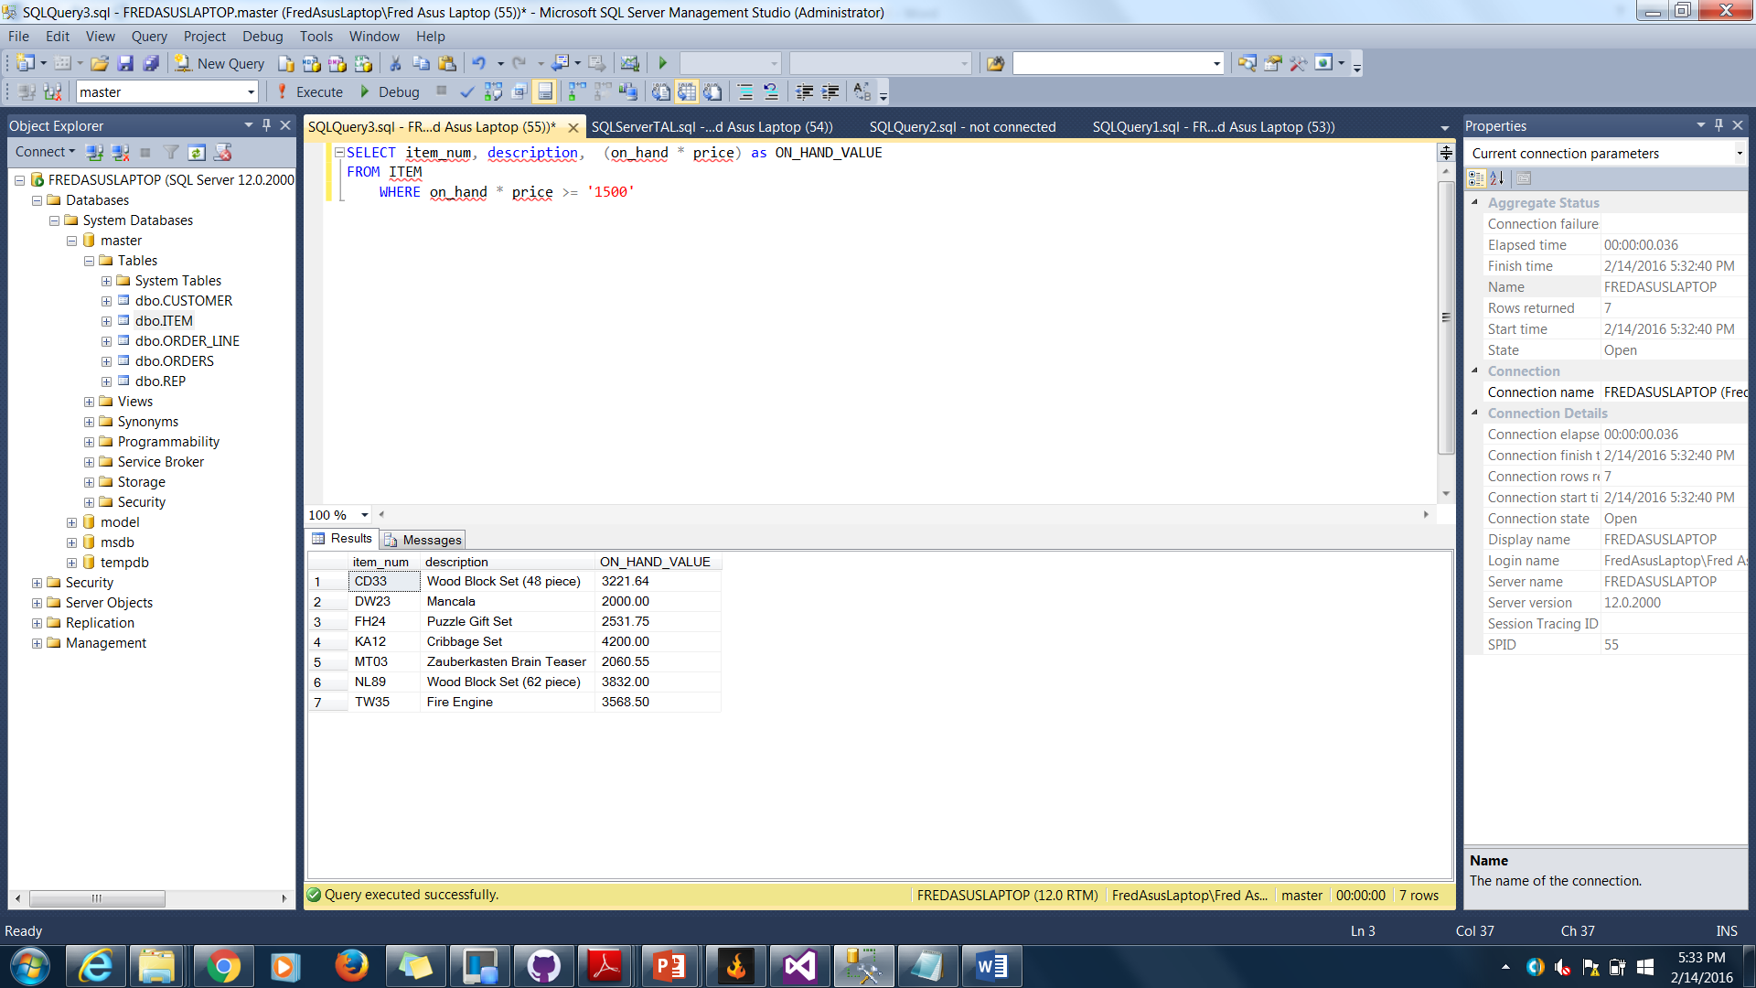

1. SELECT item_num, description

FROM ITEM

WHERE CATEGORY IN('GME', 'PZL')

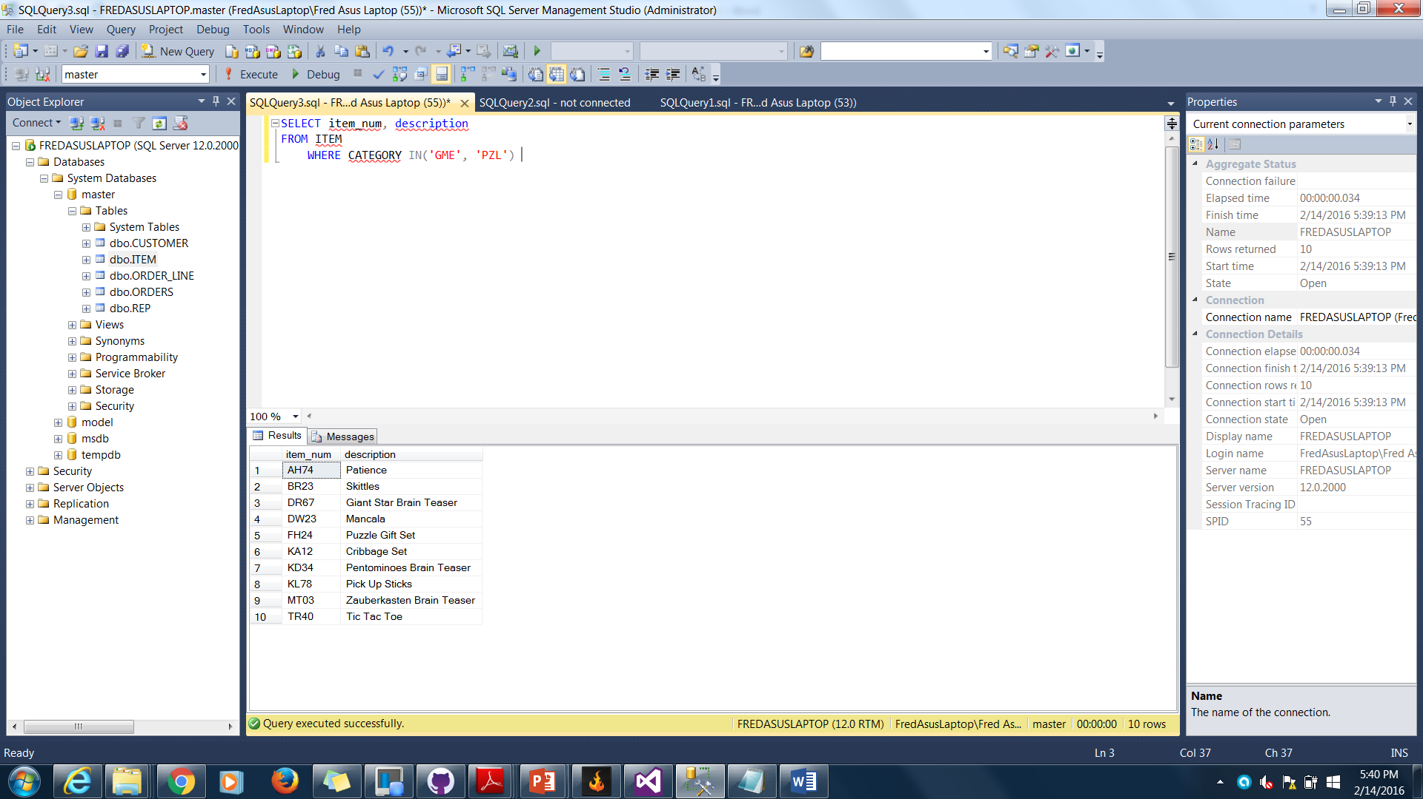

1. SELECT customer_num, customer_name

FROM customer

WHERE customer_name LIKE 'c%'

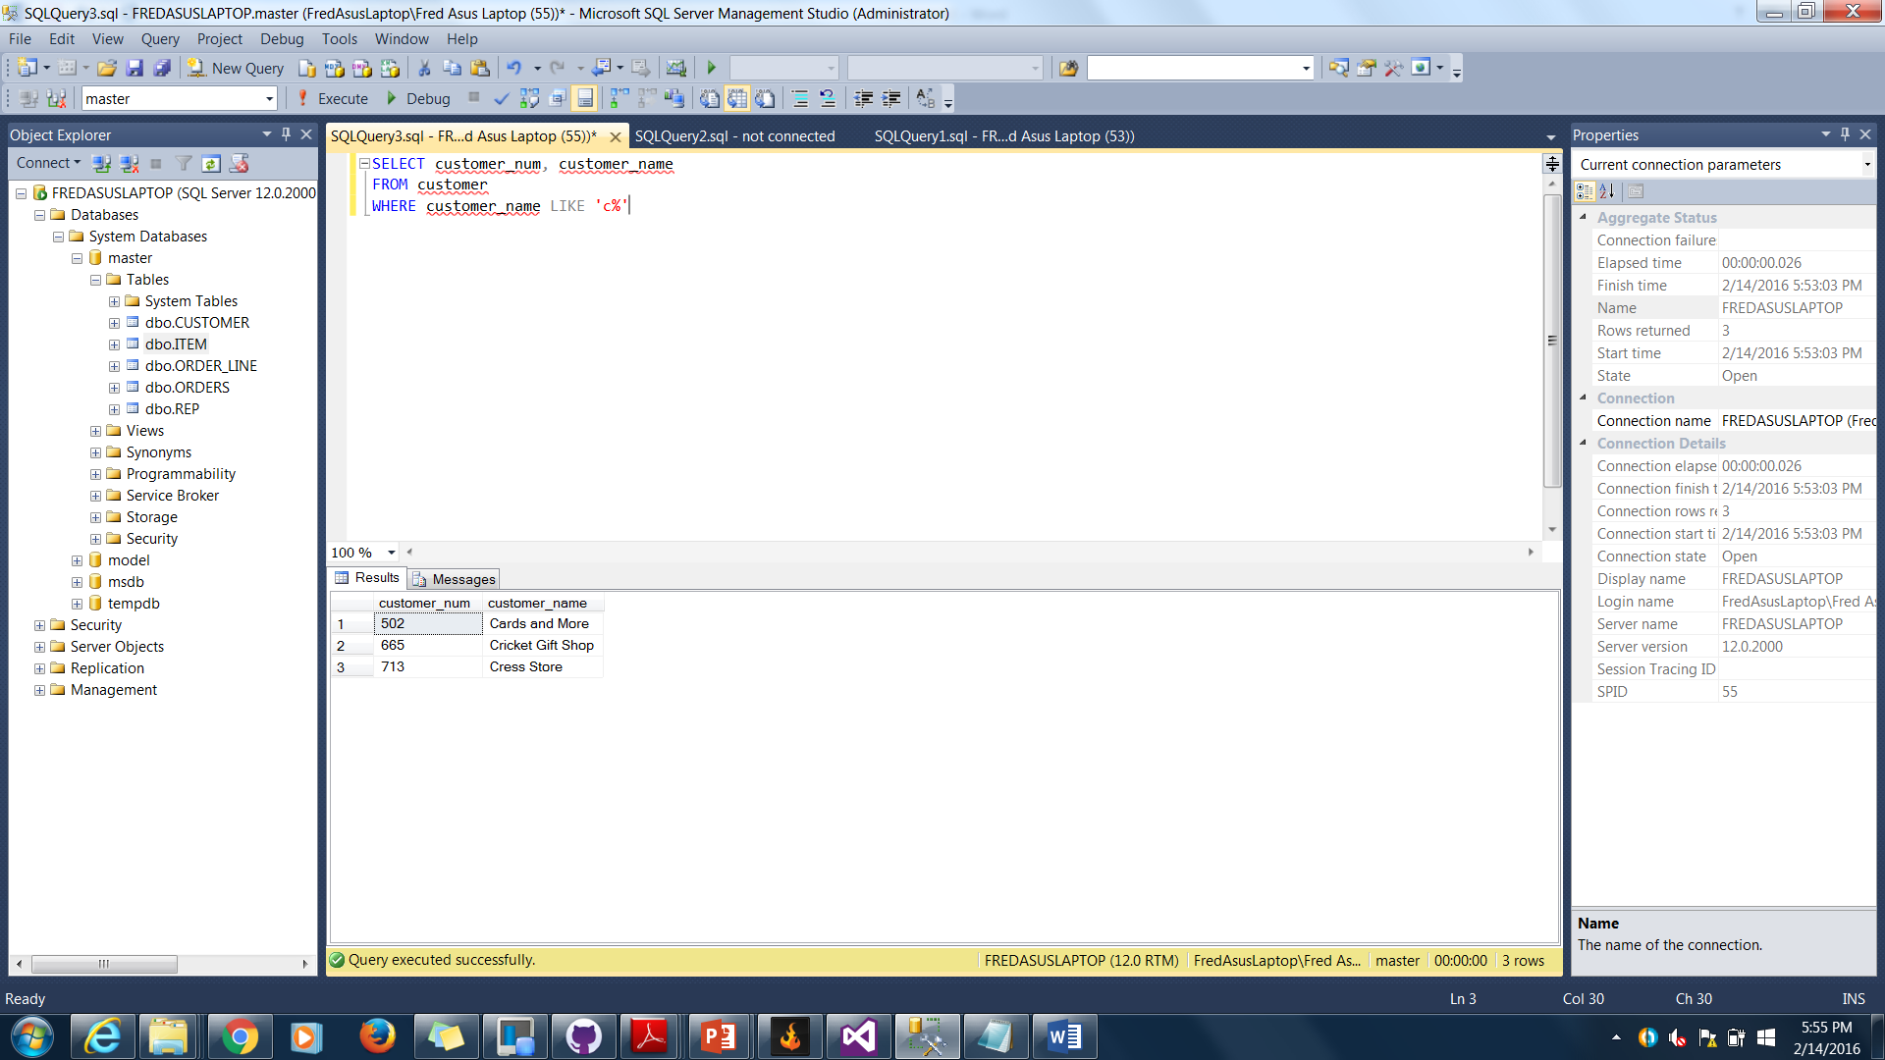

12. SELECT *

FROM Item

ORDER BY description

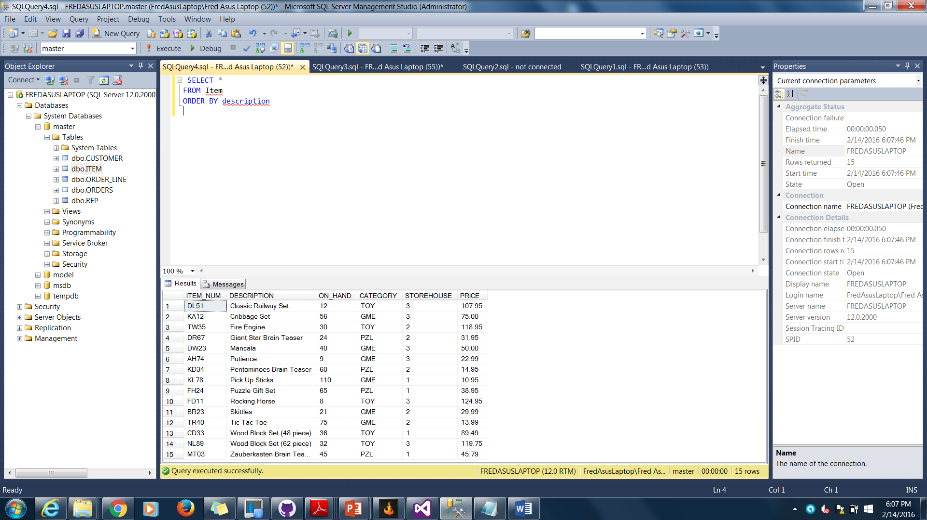

13. SELECT *

FROM Item

ORDER BY storehouse, item_num

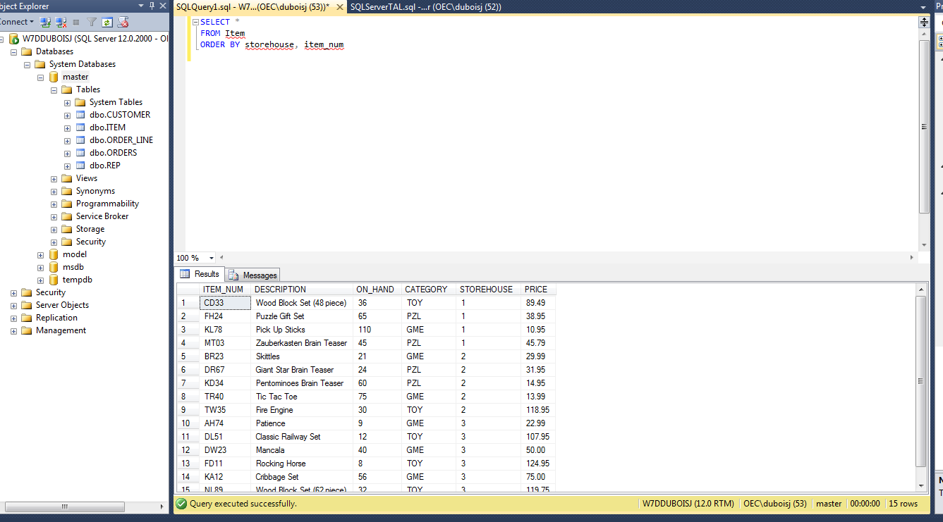

14. SELECT COUNT(*)

FROM Customer

WHERE balance > credit_limit

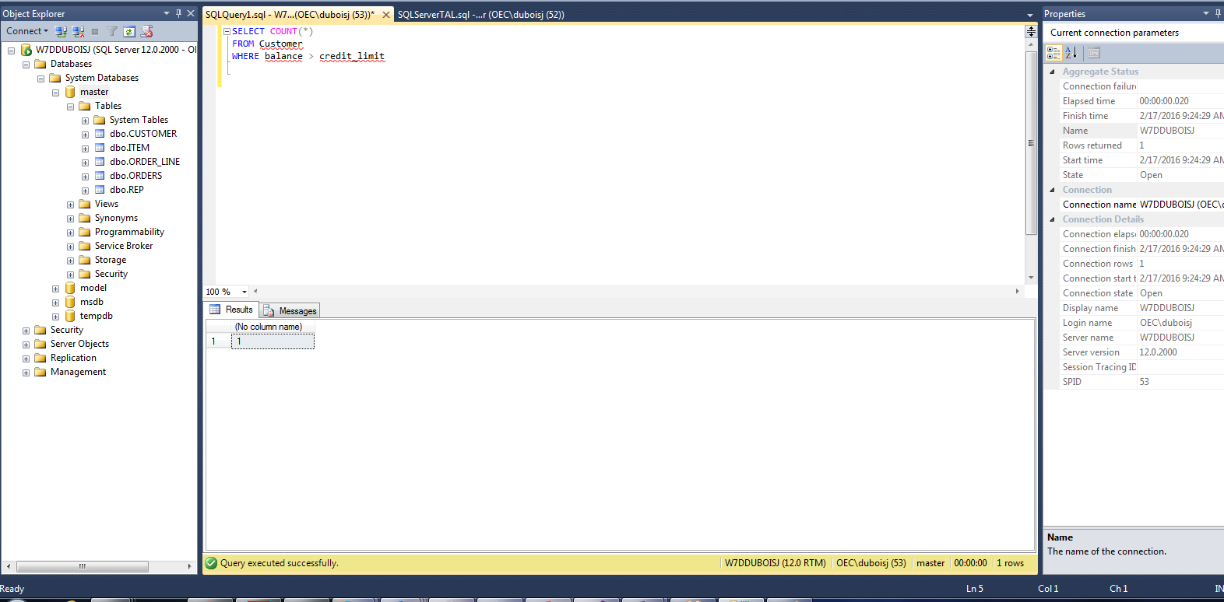

15. SELECT SUM(balance) as TotalBalance

FROM Customer

WHERE rep_num = '15' and balance < credit_limit

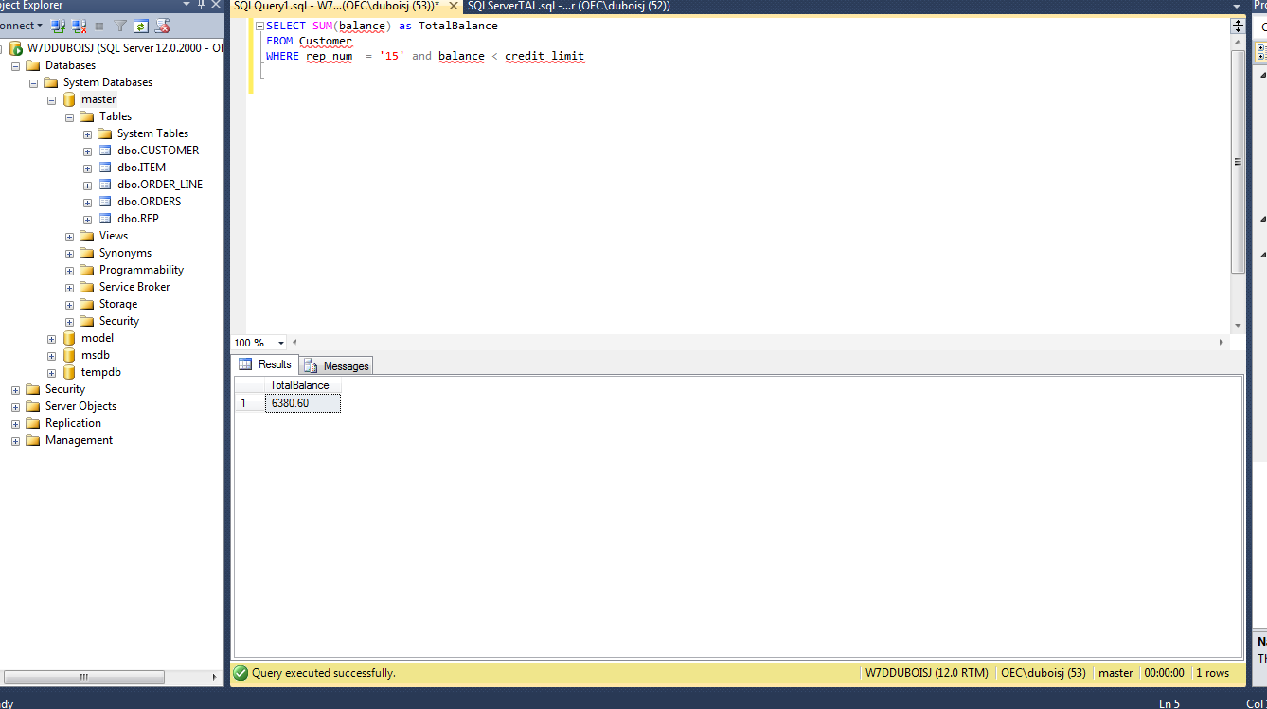

16. SELECT item_num, description, (on_hand * price) as ON_HAND_VALUE

From Item

Where on_hand > ( Select avg(on_hand)

From Item)

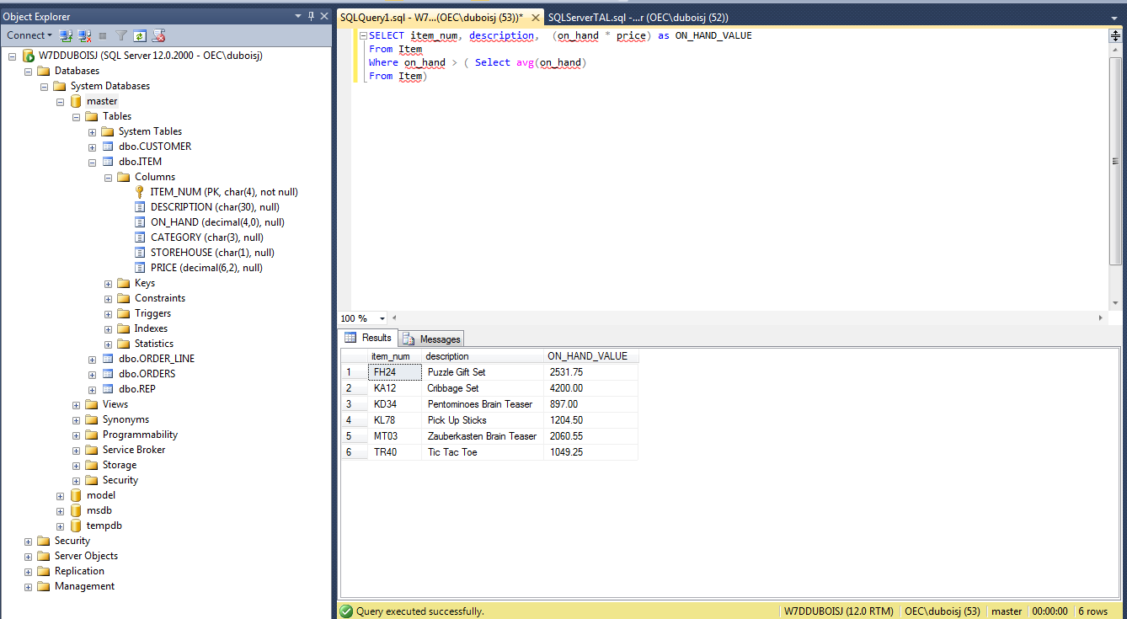

17. SELECT MIN(Price) as LeastExpensiveItem

FROM Item

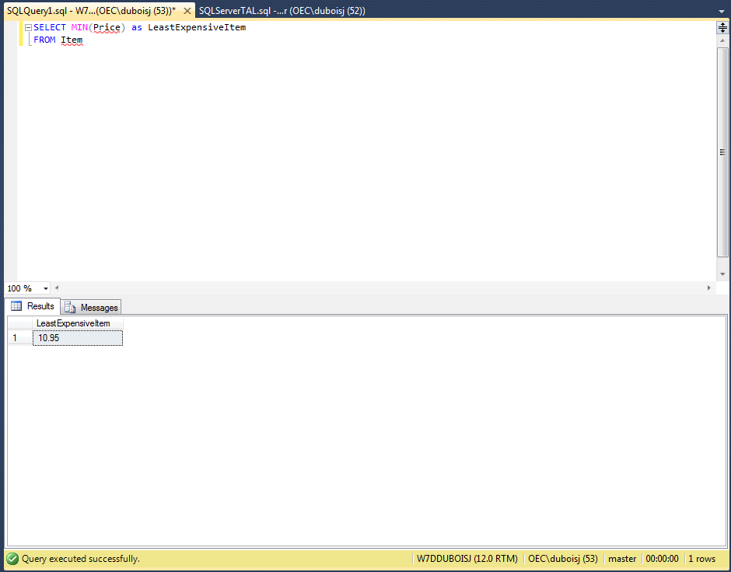

18. SELECT item_num, description

FROM Item

WHERE Price = (

SELECT MIN(Price)

FROM Item)

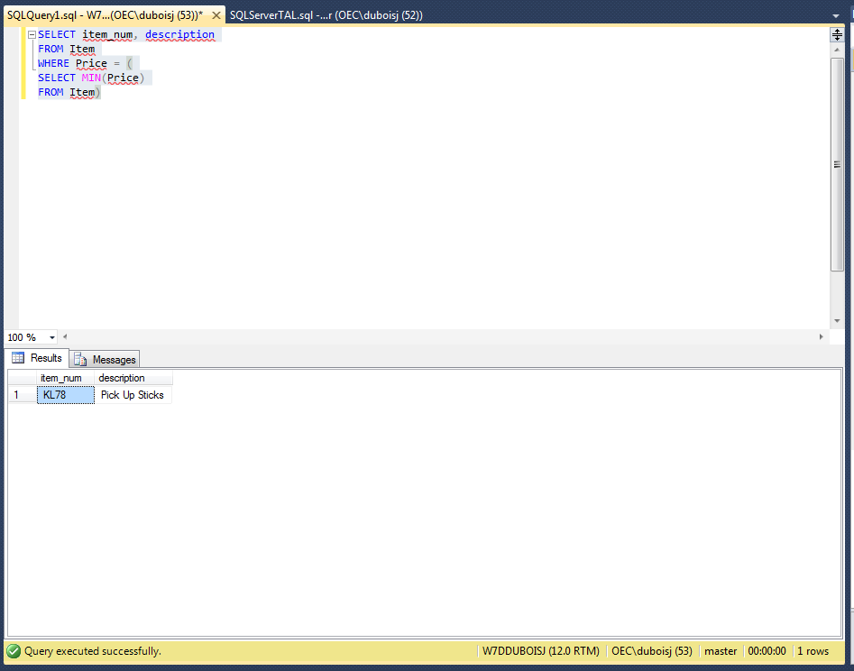

19. SELECT rep_num, SUM(Balance) as TotalBalance

FROM Customer

Group by rep_num

Order by rep_num

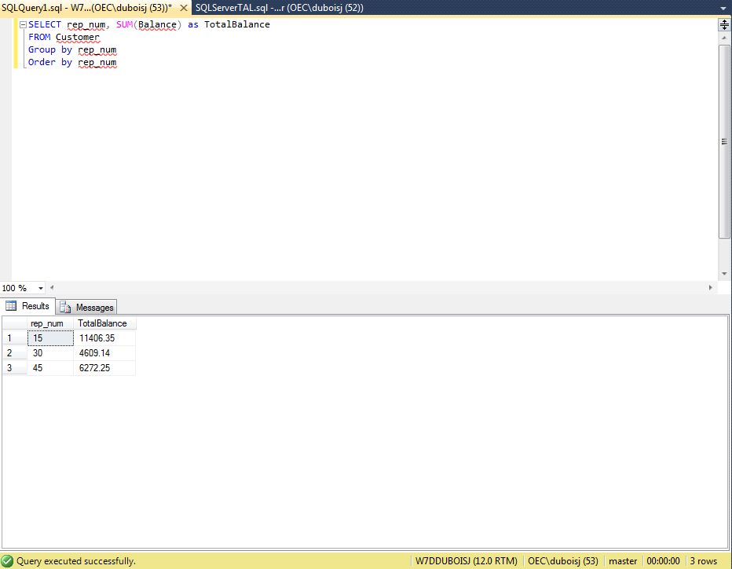

20.

21. SELECT item_num

FROM Item

WHERE description IS NULL;

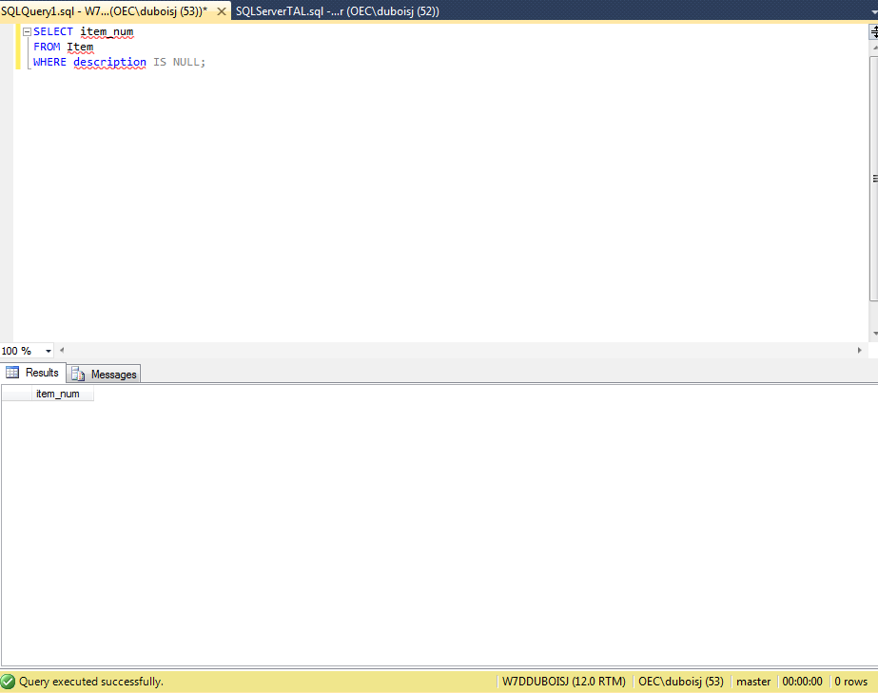

22. SELECT item_num, description

FROM Item

WHERE category = 'PZL' OR category = 'TOY' AND description LIKE '%Set%';

